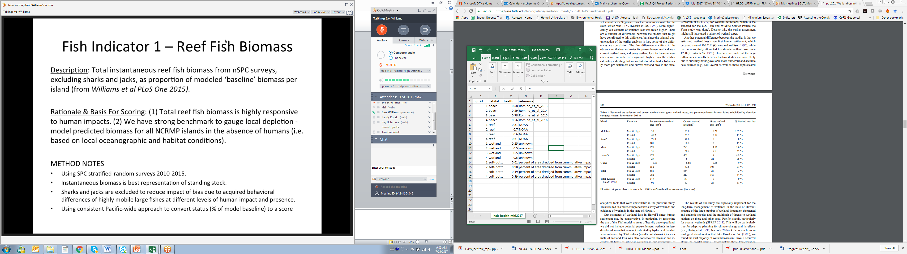

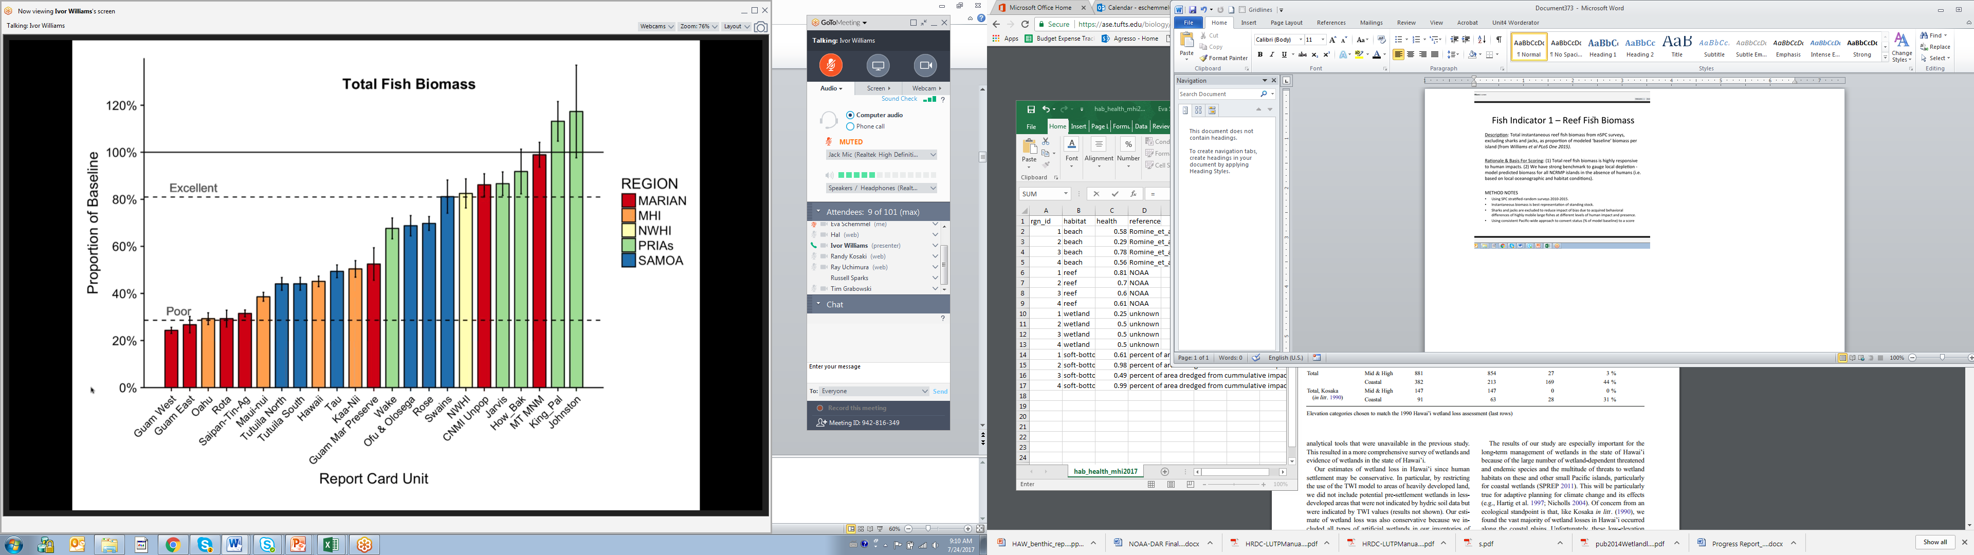

Proportion of baseline – in absence of humans Williams et al plos one 2015

A to an E grading system – score – excellent 90% > is near pristine – if sign of human impact than less than 90%

Under 80% or excellent bar for populated island

Poor and excellent values expert set – reset reference points – poor is set to E or F

10% of expected piscivores biomass is poor level

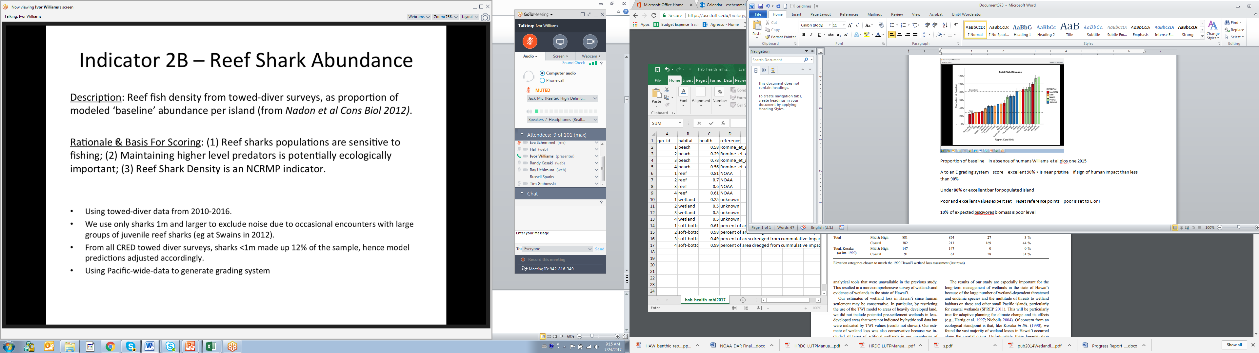

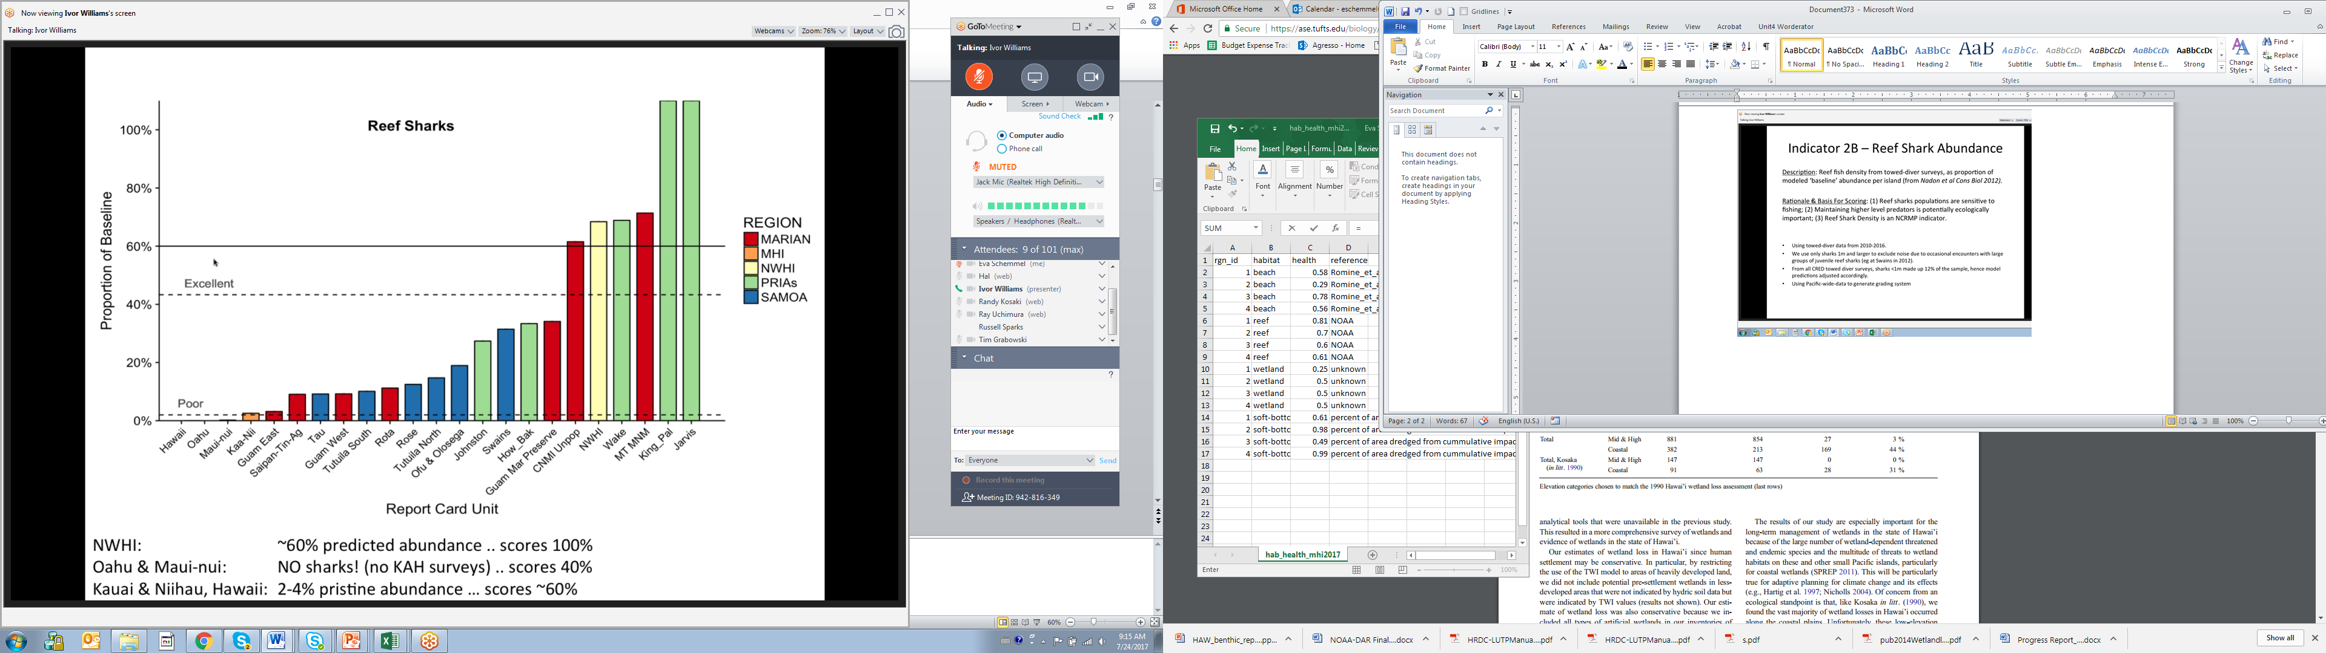

60% of reef shark biomass is excellent

Sustainability measures –

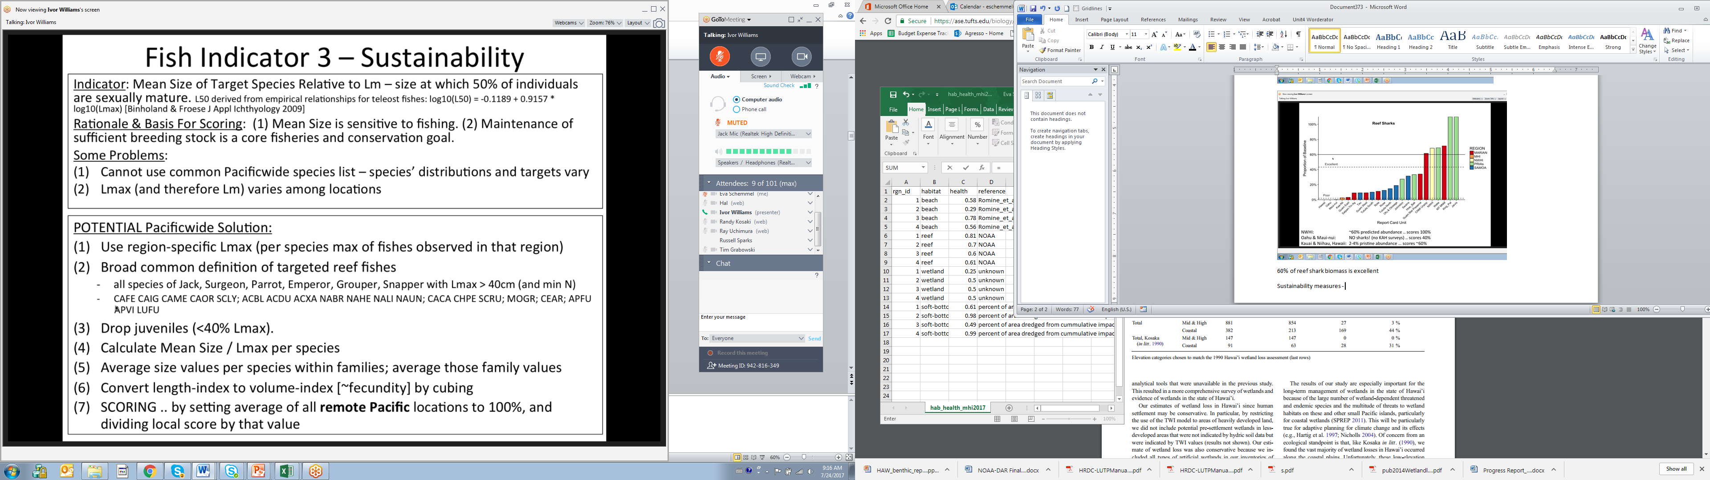

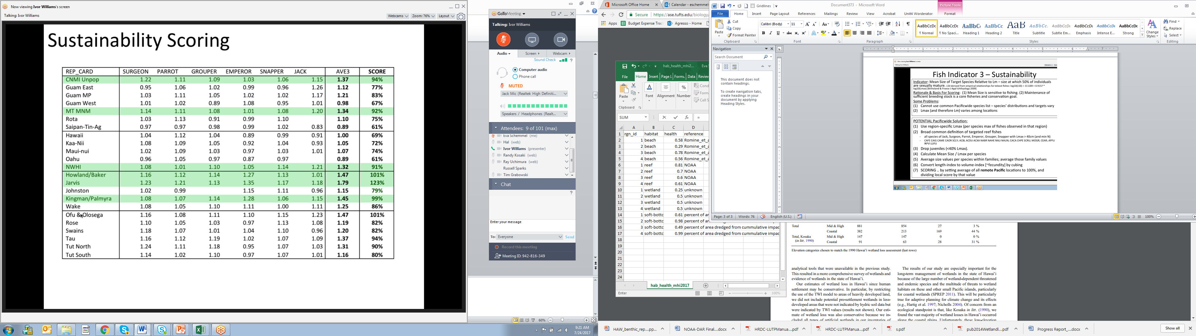

Scored relative to the average of the 6 remote locations

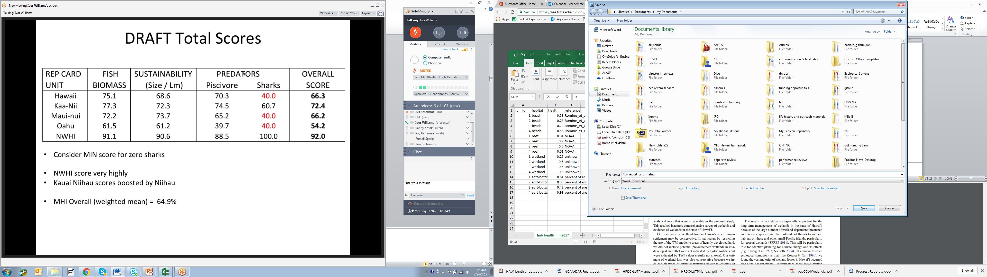

Updated metrics for report card

